Literature Review

Contents

Introduction 3

Time Management 4

The Effectiveness of Goal Visualization 5

Competitors 7

Microsoft To Do 7

Google Tasks 9

Tasks by Pocket Brilliance 11

Key Takeaways 13

Conclusion 14

References 15

# Introduction

In today’s fast-paced and digitally distracting world, effective time management and goal-setting strategies are crucial for achieving success and maintaining productivity for students and young adults. This literature review explores three critical areas to inform the development of a task manager mobile application tailored for this demographic.

Firstly, it delves into time management techniques, examining their impact on productivity and academic performance. As my mobile application will incorporate the 52/17 technique for time management, where the individual will time themselves to work for 52 minutes, and have a 17 minute break thereafter, we need to look into the scholarly works that back up this productivity technique of taking intermittent breaks.

Secondly, it investigates the importance of goal setting and goal visualization, highlighting their roles in motivating and guiding individuals through their projects, as my mobile application intends to offer the function for individuals to track and manage projects, while providing a means to visualize their progress.

Lastly, it offers a comparative analysis of existing productivity apps, identifying key features and shortcomings to ensure our app addresses unmet needs.

By synthesizing insights from these areas, this review aims to establish a robust foundation for creating a mobile application that enhances productivity and supports the goals of students and young adults.

# Time Management

A study conducted by Albulescu and colleagues, from the University of Timioara, Romania[1], delved into the effectiveness of taking micro-breaks and its impact on performance. The study was an analysis of conducted studies in the relevant field over the last 30 years on the subject of micro breaks, on whether taking short breaks of 10 minutes or less, when performing a task, leads to better performance and final outcome without accumulating too much mental and physical wear on the person to the point where is it detrimental to their health.

This investigation was motivated by the ever-increasing workload demands placed on individuals in today's modern and digitized world. The authors aimed to explore whether micro-breaks could serve as a viable solution to reduce the mental and physical strain associated with this growing burden.

Out of 4868 case studies drafted, 22 studies were finalized and narrowed down for the analysis. The participants chosen in the selected studies were healthy individuals which included both students and young adults. The measurements that were monitored and classified in this analysis were vigor, fatigue or performance. Vigor being an individual’s inclination to carry on with the task at hand, even when challenges present themselves, while fatigue relates to how tired the individual is. The performance measurements relate to whether the individual was able to perform his or her task with high degree of accuracy and precision. The tasks the participants had to perform were classified into three categories. Creative, clerical and cognitive tasks. All 22 studies had a control group as a comparison, such as those with micro break and those without.

The collective findings of the chosen studies concluded that micro breaks do indeed improve the performance and vigor of the individual whilst reducing fatigue for clerical and creative tasks, though there was barely any improvement for cognitive intensive tasks. The data uncovered that those who took breaks that were longer than 10 minutes, generally had better performance.

However, there were several key factors that had to be considered for further study. The duration of the micro break, till this day, could not be decisively agreed upon by experts in the field. The tasks in which an individual partakes prior to the break, also mattered greatly, as well as the activity the individual partakes during their break. An improvement to this analysis could have been taking the findings of the conducted studies, and perform a new bespoke experiment, comparing the results of different intervals of rest period between control groups.

This literature review supports the need and effectiveness of the 52/17 time management technique for the proposed mobile application.

# The Effectiveness of Goal Visualization

A study conducted by Cheema and Bagchi[1], was done to understand the connection visualizing goals has to an individuals continued effort to complete objective that has been undertaken. The study aims to illustrate that intuitive goals are interpreted to be easier for an individual to reach, rather than a goal further out in a given timeframe, especially when it’s broken down into sub-tasks. The study was conducted to contribute to this field of study by demonstrating how easy it is to use visualization to increase the efficiency of pursuing a goal, to identify that visualization makes the objective appear nearer, thus increasing the output exerted and demonstrate the power of visualization and reveal the boundaries conditions, particularly when the objective is framed in a consolidated manner.

A total of five studies were conducted to assess the effects of goal visualization.

The first study took 68 Olympic swimmers and had them swim 30 laps, each of which was a 100m. The measurements used was to take the difference in swim times of the first 50m, when the swimmer was facing away from the finish line, and the last 50m, when the swimmer was able to see the finish line, hence, able to visualize the end goal. The results revealed that the time difference decreased as the swimmer neared the finish line, showing a positive influence on the swimmer when he was approaching the goal, despite the presence of fatigue.

The second study took 79 students and had them sustain grip pressure for 130 seconds. The students were split into to two groups, where one had a horizontal progress bar to view on a screen, whilst the other could only view a stopwatch at 30 seconds intervals. The results found that the pressure exerted from students who were given the stopwatch, decreased significantly towards the end, compared to those who could view the horizontal progress bar, and were able to sustain a more uniform pressure. This test suggests the importance of goal proximity and in relation to effort.

The third study took 183 undergraduates and tasked them to save $750 for a fabricated vacation to Europe. There were two groups, one that could easily visualize their savings with a horizontal bar that was shaded depending on how much was already saved, 30% or 70%, whilst the other control group was only given textual representation of the savings amounts. The measurements used was a scale given to the participants to assess their commitment to reaching the required amount. The scale was based off Wright and Kacmar(1994). The results revealed those given the bar that made visualizing the amount left to save up, committed greater effort to saving than those that had a difficult time visualizing.

We can see from the first three studies conducted, they examined the subjects in settings where either their physical or mental fortitude, or both, was required to complete the tasks in various environments. And in all scenarios, the group that was able to visualize their goals, outperform the control group that either could not visualize it, or were given a poorer visualization. The findings of this review do indeed suggest that having a form of goal visualization does indeed encourage individuals to exert more effort and increase their motivation in completing their objective. The findings here support the need of having a project management tool in my task manager application, that allows users to visualize their milestones and their accomplishments, while providing an easy to visualize progress bar as to how much is left to accomplish.

However, the studies conducted above do leave room for question as to the factors that could contribute to how likely an individual is able to outperform another, given that both has access to easy visualization tools. For example, the undergraduates whose grip strength was tested, could house bias to the strength of the individual. A student with phenomenal grip strength and endurance could exert the most amount of willpower and willingness to complete the test, regardless of what goal visualization tool he was given. Thus, it is important to note an individual’s characteristics and personality might be a contributing factor when to comes to accomplishing goals.

# Competitors

The following is a critical review of similar applications that have already been published in the market. These competitors were selected for analysis due to their popularity on the Google Play Store for Android Devices. They had the highest number of downloads and appeared at the top of the search list when the words “task manager” was keyed in and searched.

## Microsoft To Do

Microsoft To Do is a productivity/to-do list mobile application developed by the tech giant Microsoft for Android and IOS devices. It was created with the intent of letting users stay organized by allowing them to create task lists, take notes and create reminders. The mobile application also allows users to sync with their Outlook, providing an integration between the two applications.

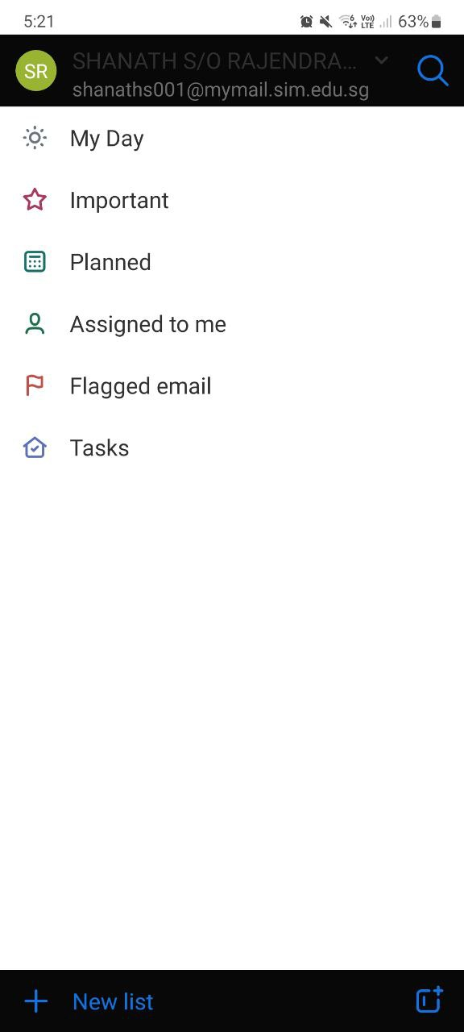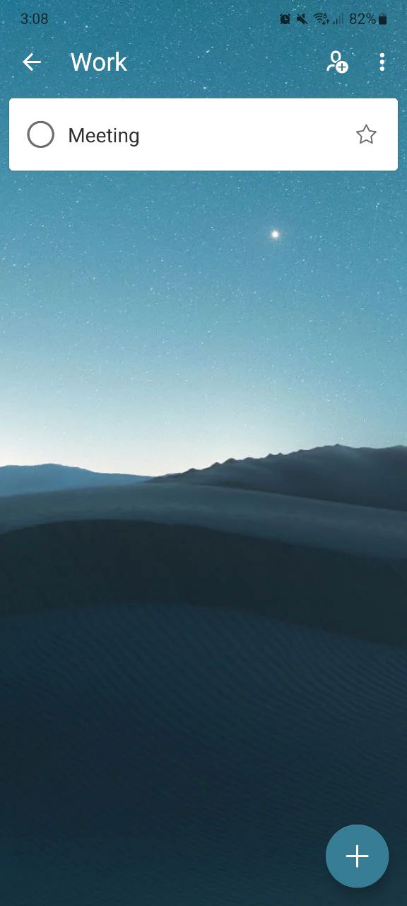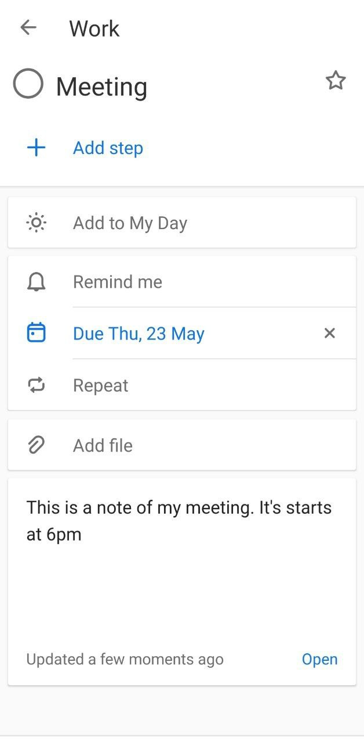

*Fig 1.1 Microsoft To Do Snapshots*

Referring to Figure 1.1, we can see snapshots of the application taken from an Android device. The analysis of the application are as follows:

1. Signing in to use the app

In order to use the application, Microsoft requires you to either sign in into a Microsoft account, or create one. The reason for this is that Microsoft wishes users to be able to sync their Outlook calendar with this task manager application. Whilst providing a seamless integration with their 3rd party applications, denying users access to the application outright because they do not posses a Microsoft account, or don’t intend to, seems to an ideal way for the individual to turn to other competitor products instead [3].

1. No tutorial upon launch

The application had no tutorial upon launch, making it difficult for users to uncover and use all the available features that are available within the application.

1. GUI and Color Design Choice

The application overall aesthetic could be better. The home page as seen in Figure 1.1, shows the top navigation bar being black, whilst the main container being white. I am unable to properly read the account that is logged in due to the contrast of colors, which is one of the key areas in GUI design[4]. Though the positive aspects of this application is that it gives the user freedom to customize the background image of their checklist.

1. Lack of Focus Tool

Our digital world is distracting. A study done by Wang and colleagues[5] noted that students have a considerable amount of digital distractions that they could turn to at a moment’s notice, such as texting and social media. A tool that could aid students in focusing and managing their time, as discussed in the Time Management section, could prove fruitful.

1. Lack of Project Management

The application presents no tool for users to undertake and manage large scale projects, and houses no way to visualize the progress being made. The need for this feature, is backed up by a study done by the U.S. Department of Labor showed that 78% of the population, spent their days engaged in household activities while 44% of the population were engaged in work/work related activities. This indicates users have many tasks to accomplish on a daily basis. A tool to help visualize their accomplishments would be ideal, as it increases their effort exerted and motivation to complete the objective, as seen in the literature review above.

## Google Tasks

Google Tasks is a productivity mobile app designed to help users manage their to-do lists and tasks efficiently. It integrates seamlessly with other Google services like Gmail and Google Calendar, allowing users to create, view, and manage tasks across multiple platforms.

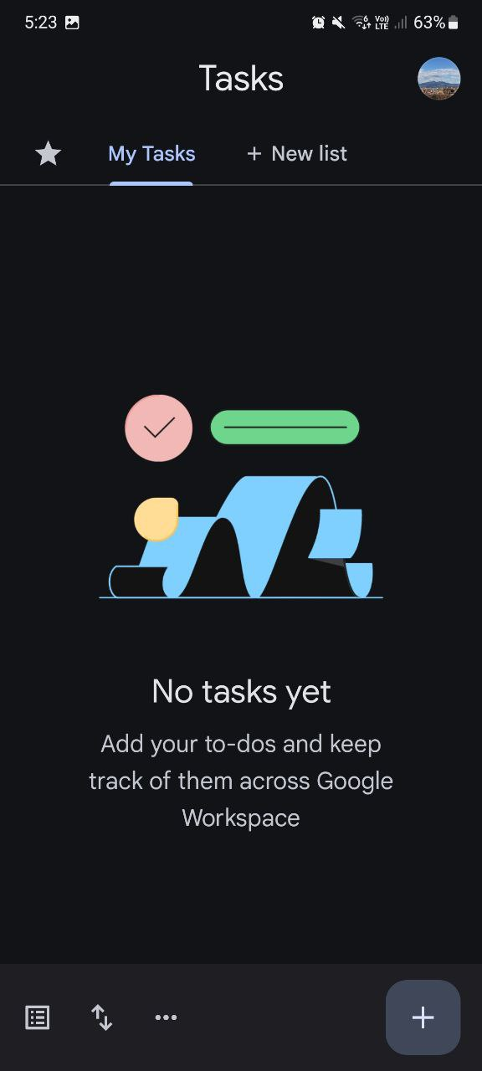 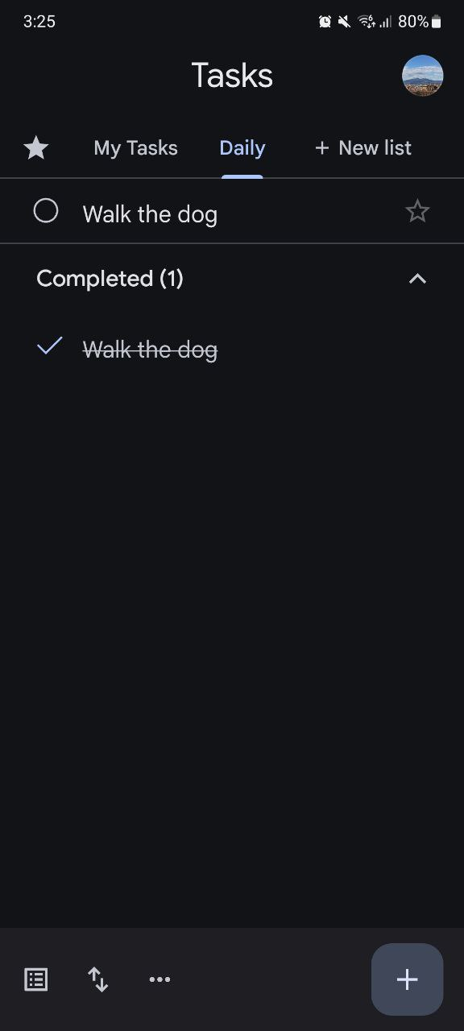

*Fig 1.2 Google Tasks Snapshots*

Referring to Figure 1.2, we can see snapshots of the application taken from an Android device. The analysis of the application are as follows:

1. Good integration of APIs

Unlike Microsoft, Google does not force users to sign into a Google account in order to use their application. Instead, the basic functionality of to-do lists, sub-tasks and notes are available to user, and those that wish to sync their tasks created on Gmail and Google Calendar, can log in to do so.

1. No tutorial upon launch

The application had no tutorial upon launch, making it difficult for users to uncover and use all the available features that are available within the application.

1. GUI and Color Design Choice

The application overall aesthetic is good. Referring to Figure 1.2, we can see the design choice Google has adopted is the flat UI approach[6]. This provides a clean and easy interface to navigate.

1. Lack of Focus Tool

Like Microsoft, a tool that could aid students in focusing and managing their time, as discussed in the Time Management section, could prove fruitful.

1. Lack of Project Management

Like Microsoft, this application presents no tool for users to undertake and manage large scale projects, and houses no way to visualize the progress being made, as seen in the literature review above.

## Tasks by Pocket Brilliance

Tasks by Pocket Brilliance Limited is another task manager application available from the Google Play Store. A review of this application reduces the bias of only analyzing task manager applications from already established technology giants. 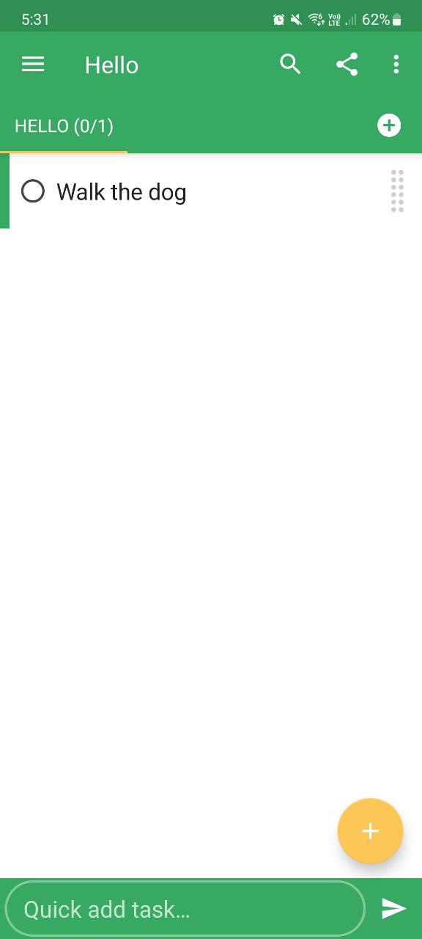 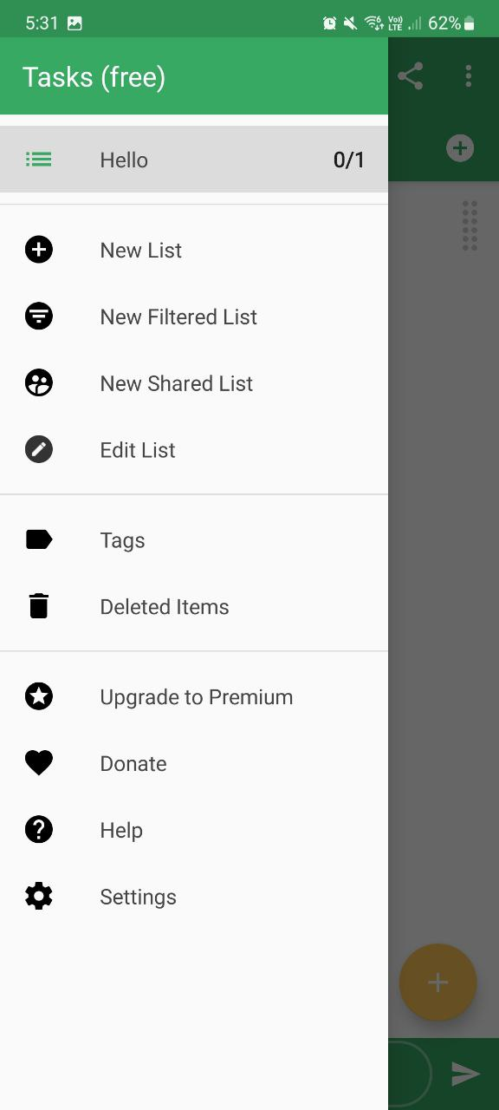

*Fig 1.3 Tasks by Pocket Brilliance Snapshots*

Referring to Figure 1.3, we can see snapshots of the application taken from an Android device. The analysis of the application are as follows:

1. Minimal API and Sync

This application uses minimal API such as calendar and syncing the application and its data across multiple devices. It does not require users to log in or create account. However, it does require users to purchase the premium version of the application, in order to synchronize across devices.

1. Privacy

This application prides itself in no collecting and sharing user’s data to third party services, which is a good practice to entice users to use their application instead, as data collection from corporations is rampant in today’s world[7]. There is no ethical breach.

1. Poor tutorial and settings page

The application has a poor tutorial then only activates once users start to interact with the application. It does not give the option to replay the tutorial in the settings page, which is extremely cluttered with many nuanced setting parameters.

1. GUI and Color Design Choice

The application overall aesthetic is good. Referring to Figure 1.3, we can see the design choice it has adopted, is the flat UI approach[6].

1. Lack of Focus Tool

Once again, a tool that could aid students in focusing and managing their time, as discussed in the Time Management section, could prove fruitful.

1. Lack of Project Management

Once again, this application presents no tool for users to undertake and manage large scale projects, and houses no way to visualize the progress being made, as seen in the literature review above.

## Key Takeaways

|  |  |  |  |
| --- | --- | --- | --- |
| Name of Application | Good Practices | Bad Practices | Carry Over |
| Microsoft To Do | * Allows customization via images | * Forcing users to sign in * Bad design principle * No tutorial * No focus tool * No project tool | * Allow image customization * Include focus & project tool * Include a tutorial * Do not force users to sign in * Select proper design principles |
| Google Tasks | * Great UI design choice, flat principle | * No tutorial * No focus tool * No project tool | * Carry over flat principle and minimalism design * Include focus & project tool * Include a tutorial |
| Tasks by Pocket Brilliance | * Minimalize use of 3rd party API * No ads or data collection * Minimalist and flat UI approach | * No focus tool * No project tool * Overwhelming settings page | * Use 3rd party services only when necessary * Do not collect data or house advertisements * Adopt a minimalist approach |

# Conclusion

In summary, the literature review comprised of three key components. We discussed why the need for having a time management tool is important for students to maintain productivity and focus through a review of a study conducted by experts in the field, regarding the use of micro breaks when accomplishing a task. The need for goal visualization for adults in a work environment was also reviewed, and we saw the positive impact it made on individuals when a visualization tool was present. Finally, we compared previous work done by competitors, and analyzed their strength and weaknesses, and what I will be carrying and not carrying over into my application, based off a thorough analysis and review.

# References

[1] Albulescu, P., Macsinga, I., Rusu, A., Sulea, C., Bodnaru, A. and Tulbure, B.T. (2022). ‘Give me a break!’ A systematic review and meta-analysis on the efficacy of micro-breaks for increasing well-being and performance. *PLOS ONE*, [online] 17(8), p.e0272460. doi:https://doi.org/10.1371/journal.pone.0272460.

[2] Cheema, A. and Bagchi, R. (2011). The Effect of Goal Visualization on Goal Pursuit: Implications for Consumers and Managers. Journal of Marketing, 75(2), pp.109–123. doi:https://doi.org/10.1509/jm.75.2.109.

[3] Underwood, J. (2017). Learning 001: Sometimes you shouldn’t force user login, even if everyone says you should. [online] Medium. Available at: https://medium.com/@JUnderwood/learning-001-sometimes-you-shouldnt-force-user-login-even-if-everyone-says-you-should-96dd4c416487

[4] Figma (2023). 5 key UI design principles— and how to use them | figma. [online] Figma. Available at: https://www.figma.com/resource-library/ui-design-principles/.

[5] Wang, C.-H., Salisbury-Glennon, J.D., Dai, Y., Lee, S. and Dong, J. (2022). Empowering College Students to Decrease Digital Distraction through the Use of Self-Regulated Learning Strategies. Contemporary Educational Technology, [online] 14(4). Available at: <https://eric.ed.gov/?id=EJ1364826>.

[6] DesignerUp. (2023). 6.5 of The Most Popular UI Design Trends and Styles Explained. [online] Available at: <https://designerup.co/blog/here-are-6-5-of-the-most-popular-ui-design-trends-and-how-to-design-them/>.

[7] www.privacyjournal.net. (2022). Big-Tech Data Collection: Protect Your Info 2024. [online] Available at: https://www.privacyjournal.net/big-tech-data-collection/.

‌

‌

‌

‌

‌

‌